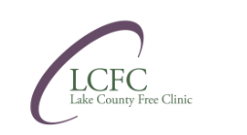

Strategic Plan 2025-2029
ll

LETTER FROM Executive Director
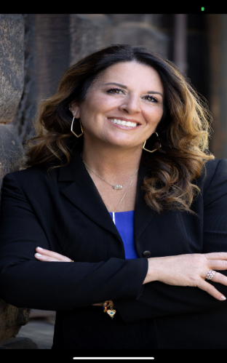

Dear Friends of Lake County Free Clinic,
In May 2025, Lake County Free Clinic embarked on a comprehensive, forward-looking strategic planning process to shape our future. We recognized that, in today’s healthcare landscape—marked by unpredictable policy shifts, rapid technological advances, and changing community demographics—proactive planning is more essential than ever.
Our strategic planning journey was both rigorous and inclusive. We examined nearly every facet of our organization and actively engaged with the people who make our work possible. Patients, staff, board members, volunteers, philanthropic partners, donors, and community leaders contributed invaluable insights through focus groups, feedback sessions, and collaborative discussions. To each of you who shared your time, expertise, and vision—thank you.
Of course, a plan is only the starting point. Bringing these goals to life will require shared commitment, measurable benchmarks, and the flexibility to adapt as we learn. Together, we will hold ourselves accountable and remain steadfast in our mission.
LCFC’s history is rooted in rock-solid values, an unwavering commitment to volunteerism, and a culture that turns challenges into opportunities. While the future will always bring uncertainty, we are confident this plan will serve as our guide—ensuring we continue to provide essential, compassionate care for those who need it most.
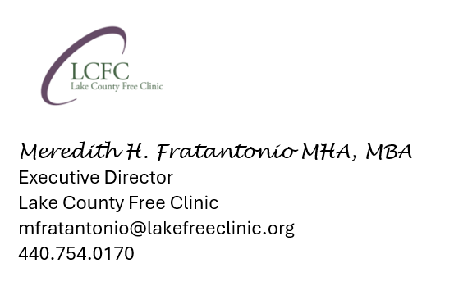

THE STRATEGIC PLANNING PROCESS


This plan sets LCFC’s course for the next four years, detailing the critical initiatives needed to ensure our patients continue to receive quality, patient- centered health care. It was created by LCFC staff over a six-month period and made stronger with input and insight from our Board of Directors, subject matter experts, and many other stakeholders.

Our planning work included:

- Internal assessment activities: reviewing the clinic structure, processes, operations,
data and trends.

- External assessment activities: identifying and assessing changes and trends likely to have a significant impact on the clinic and conducting learning conversations with other organizations of interest.

- Convening patient satisfaction surveys, and meeting with local safety-net organization representatives (both medical and non-medical, including United Way of Lake County and Lake County Accelerator Program).

- Meeting with funding organizations.

- Communicating with local, regional and national free clinic organization leaders and elected officials, and

- Enlisting staff, volunteers, and interns help.

Our planning team distilled the volume of data and other information into a list of the most salient issues, sharing them with the Board of Directors. Our active discussion around matters related to demography and the environment, politics and policy, technology, the economy and health sciences informed our Strengths/Weakness- es/Opportunities/Threats (SWOT) Analysis activity, which yielded the following significant themes:

- LCFC’s mission and culture are special, well- regarded, philanthropically supported and worthy of preserving.

- The need in Northeast Ohio for our comprehensive, compassionate, and quality services by patients/prospective patients and community partners alike will continue for the foreseeable future.

- Our pool of dedicated volunteers—so essential to our operations—is evolving and we must prepare accordingly.
Focus Area 5: Expanding Landscape for Improved Patient Care

  - Institutional grant support for healthcare is gradually shifting focus to health (in the broadest sense) and addressing the root causes of health disparities such as poverty, social isolation and diminished advancement opportunities; Building on our collaborative safety-net partnerships while continuing to deliver comprehensive services under one roof is imperative.

These themes underline the strategic initiatives organized within one
of the following areas of focus:
Focus Area 1: Revenue Diversification / Financial Stability

Focus Area 2: Marketing Outreach & Brand Recognition

- The growing demand for data by our stakeholders will require us to update our tools and systems to support efficient data collection, analysis, reporting and decision-making

- The federal/state political environments and associated policy implications are dynamic, and we must remain attentive and ready for various scenarios.

Focus Area 4:
Organizational Capacity & Talent Development
Focus Area 3: Strategic Partnership & Community Engagement

Moving forward, annual goals (action plans) will be set to ensure successful execution of the plan, with milestones and target dates to track progress. As well, our strategy will be revisited from time to time and adjusted as needed, given the dynamic environment and times in which we operate.


WHO WE ARE
Mission

LCFC’s mission is to address the unmet healthcare needs of the residents of our community and beyond through the provision of quality medical, dental and health education services.

Vision Statement
An engaged community in which healthcare needs are
met with high quality care while maximizing community resources.

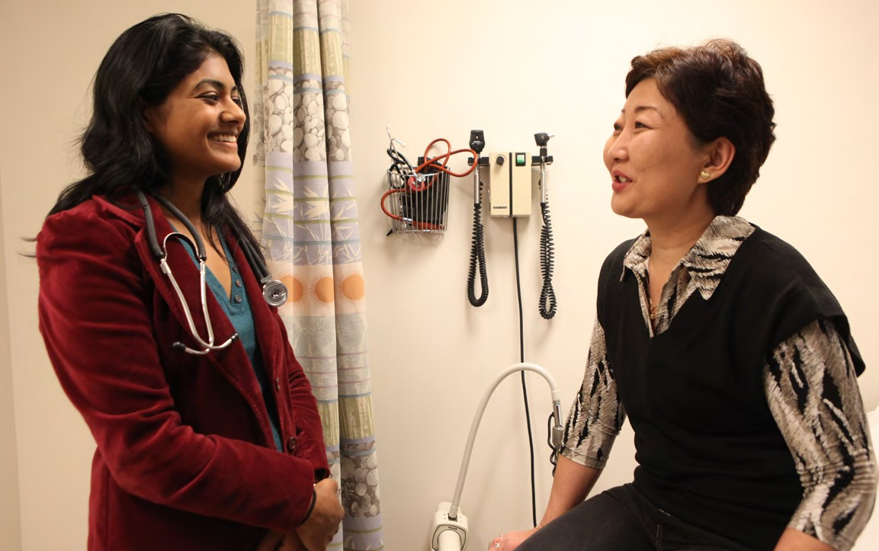
Core Values
We believe in patient-centered, high quality, professional healthcare that is compassionate, caring and empowering.
Our core values support this belief.

RESPECT
Safeguard and promote health and well-being of the community.
COMPASSION
Patients are treated with respect and dignity.
EXCELLENCE
Strive to provide the highest level of care by maintaining organizational excellence through the use of best practices.
TEAMWORK
Good steward of highly valued resources (i.e. volunteers).
STEWARDSHIP
Serve as the health safety-net for the community.
GRATITUDE
Foster personal responsibility among patients to seek enhanced health and wellness.

GUIDING PRINCIPLES
The following principles define how Lake County Free Clinic conducts itself in its many roles—as a nonprofit organization delivering healthcare, a workplace for a family of staff and volunteers, and an integral member of the safety-net community. We hold ourselves accountable to our patients, our supporters and each other by remaining mission-focused every day in our service to Northeast Ohio’s underserved.

We are committed to operating LCFC in a way that:

  - Nurtures true partnerships between patients, staff, volunteers and community partners
  - Leverages our partnerships to deliver holistic, quality care to our patients.
  - Involves patients and their families/caregivers in developing and taking ownership of their care plan.
  - Preserves our core values.
  - Supports thoughtful growth and spending.
  - Balances and optimize our diverse income streams.
  - Leverages our resources to make effective use of technology.
  - Employs impactful and timely communications.
  - Uses data to shape perspective and drive decision-making.
  - Fortifies our role and reputation as a reliable partner in the greater community.

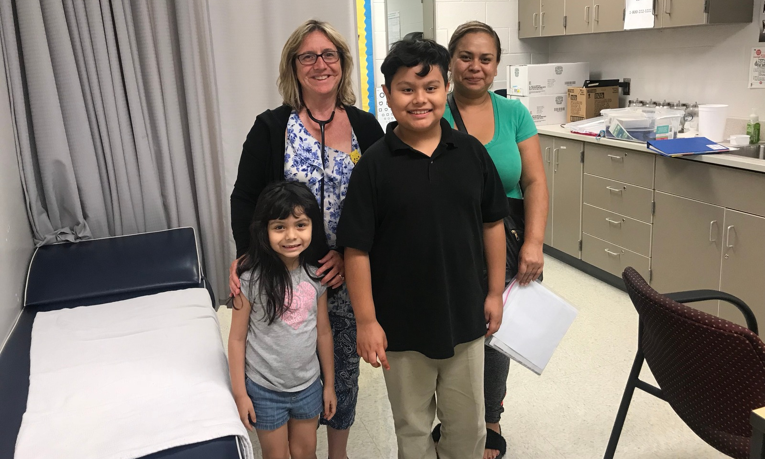
FOCUS AREA 1: Revenue Diversification and Financial Resilience
Broaden and strengthen funding sources to ensure long-term financial stability, reducing reliance on any single revenue stream and enabling sustainable growth.
Our selected strategies are to:

1.2 Utilize data to demonstrate quality and outcomes that can create new funding opportunities (e.g., value-based contracts, partnerships).

Context: Demonstrating the clinic’s impact through measurable outcomes strengthens credibility with funders and partners. Leveraging data to showcase quality of care can open doors to value-based contracts, strategic partnerships, and other funding opportunities that support sustainability and growth.

1.1 Improve revenue diversification by exploring new funding streams beyond grants and donations.

Context: Relying solely on grants and donations makes the clinic financially vulnerable. Expanding revenue sources—such as social enterprise activities, service contracts, or partnerships—will create a more stable funding base, reduce risk, and ensure sustainable access to no-cost care.

1.3 Leverage our history of successful capital campaigns and small mortgage to plan and launch a new fundraising initiative for expanded services.

Context: LCFC’s proven track record with capital campaigns and its low mortgage position provide a strong foundation for launching a new fundraising initiative. Building on this history will help secure resources needed to expand services and meet increasing community demand.

1.4 Mitigate risks from potential
decreases in grant funding and donor contributions by building a reserve fund and identifying alternative revenue sources.

Context: Fluctuations in grant funding and donor contributions pose ongoing financial risks. Establishing a reserve fund and pursuing alternative revenue sources will protect LCFC’s stability and ensure uninterrupted care for the community.

Goal: LCFC hours-of-operation will more closely aligned with community needs and patients express satisfaction with the ease and timeliness of scheduling of appointments

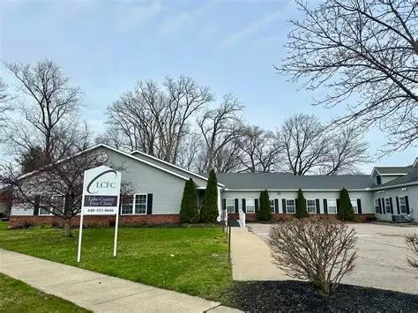

FOCUS AREA 2: Marketing Outreach and Brand Recognition
Enhance visibility, credibility, and community engagement through strategic marketing, consistent branding, and targeted outreach to key stakeholders., we must focus efforts to:
2.1 Define and create a clear, cohesive brand identity to increase public awareness and reach.

Context: A clear and consistent brand identity will help LCFC stand out, communicate its mission effectively, and build trust with the community. Strengthening brand recognition will expand public awareness, deepen engagement, and extend the clinic’s reach to patients, partners, and supporters.
Goal: LCFC’s effective integration into the Northeast Ohio’s safety network will be reflected in an increased number of community partners, fulfilled and timely patient cross-referrals, and self- reported patient and partner satisfaction.

2.2 Improve our marketing strategy using digital platforms and
community engagement.

Context: Enhancing LCFC’s marketing through targeted digital platforms and active community engagement will broaden outreach, strengthen relationships, and showcase the clinic’s impact. A more strategic approach will help attract patients, volunteers, and supporters while reinforcing LCFC’s role as a trusted community resource.

2.3 Promote our longstanding reputation in the community to attract supporters, volunteers, and donors.

Context: LCFC’s decades-long history of providing compassionate, high-quality care has earned deep trust in the community. Showcasing this reputation will help inspire new supporters, engage dedicated volunteers, and attract donors who share the clinic’s commitment to improving health for all.



2.4 Use outcome and impact data to strengthen marketing and
storytelling for funding appeals and public trust.

Context: Effectively sharing LCFC’s outcome and impact data will make funding appeals more compelling and reinforce public trust. By integrating data into marketing and storytelling, the clinic can clearly demonstrate its value, inspire support, and highlight the difference it makes in the community.
FOCUS AREA 3: Strategic Partnerships and Community Engagement
Cultivate and maintain strong external relationships that expand referral networks,
foster collaboration, and increase

Goal: LCFC personnel and volunteers will adeptly use the data at their disposal to expand their varied clinical roles
organizational influence.
We will drive organizational excellence
by concentrating our attention and
resources on the following
objectives:

3.1 Build and expand collaborations by leveraging our community
reputation to partner with healthcare providers, nonprofits, and civic organizations.

Context: LCFC’s strong community reputation positions it well to form meaningful collaborations. Expanding partnerships with healthcare providers, nonprofits, and civic groups will enhance service capacity, share resources, and amplify the clinic’s impact in addressing community health needs.

Goal: Increase the number of new sources of institutional funding of LCFC’s existing or
planned programs/services (and partners who collaborate
in acquiring it).
3.2 Minimize direct impact and
mitigate adverse effects of governmental policies on patients through advocacy and education.
Context: Governmental policies can significantly affect the health and well-being of LCFC’s patients. Proactive advocacy and education efforts are essential to minimize negative impacts, inform the community, and influence policies that support equitable access to care.

FOCUS AREA 4: Organizational Capacity and Talent Development
Invest in staff, volunteer, and leadership growth to strengthen internal capacity, improve operational efficiency, and foster a culture of innovation and excellence.
Achieving our internal development goal demands that we:

4.2 Improve staff development through regular training, professional growth opportunities, and retention strategies.

Context: Investing in staff development through ongoing training, career growth opportunities, and retention initiatives is essential to maintain a skilled, motivated workforce. Strengthening staff capacity supports high-quality patient care and ensures LCFC’s long-term organizational success.

Goal: Commitment to increasing the number of new and sustained Individual donors and their giving.
4.1 Develop the Board of Directors by recruiting members with expertise in IT, finance, and community engagement.

Context: To effectively navigate growing operational and strategic demands, LCFC needs a Board with diverse expertise. Recruiting members skilled in IT, finance, and community engagement will strengthen governance, support informed decision-making, and enhance connections to key community resources.

Goal: Develop dashboard reports of trends, volumes, and characteristics of LCFC patients to allow continued development of care pathways and inform decision-making
4.3 Minimize the potential for
language barriers by increasing
access to interpreters and
multilingual staff training.

Context: Language barriers can hinder effective communication and impact quality of care for diverse patient populations. Increasing access to interpreters and providing multilingual training for staff will improve patient understanding, satisfaction, and health outcomes.

4.4 Strengthen internal systems to support sustainability, innovation, and responsiveness to emerging challenges.

Context: Robust internal systems are vital for LCFC to sustain operations, foster innovation, and adapt quickly to emerging challenges. Strengthening these systems will enhance efficiency, improve service delivery, and position the clinic for long-term success.


FOCUS AREA 5: Service Expansion and Patient-Centered Innovation
Continuously assess community needs and leverage emerging opportunities to expand services, integrate new care models, and improve patient outcomes.
Achieving our resource development goal demands that we:

5.1 Expand patient care services using capital campaign strategies and data-driven planning.

Context: Expanding patient care services requires strategic investment and informed decision-making. Utilizing capital campaign strategies alongside data-driven planning will enable LCFC to effectively raise resources and allocate them to meet evolving community health needs.

Goal: Addition of nourish pantry to allow LCFC to integrate unmet SSDoH with chronic condition education and management.

5.2 Enhance support from the medical community by developing referral partnerships and demonstrating care quality through data.

Context: Building strong referral partnerships and showcasing care quality through data are key to gaining support from the broader medical community. These efforts will enhance collaboration, increase patient access, and strengthen LCFC’s reputation as a trusted healthcare provider.

5.3 Address transportation concerns by exploring partnerships with ride-share programs, local agencies, or grant-funded transportation assistance.
Context: Transportation barriers limit many patients’ access to healthcare services. Exploring partnerships with ride-share programs, local agencies, and transportation assistance grants will help LCFC reduce these obstacles, improving patient attendance and continuity of care.


5.4 Use outcomes data to explore integration of new services and justify funding requests that enhance patient care.

Context: Leveraging outcomes data allows LCFC to identify opportunities for new service integration and provides evidence to support funding requests. This data-driven approach ensures resources are aligned with patient needs and enhances the quality of care delivered.

ACKNOWLEDGEMENTS

We are grateful for the input of our partners, supporters and employees during
the strategic planning process.

Lake County Free Clinic Board Members
All of whom provided thoughtful input and supported the end-product.

Susan Deming, RN
Chair/President
Retired / Lake Health

Cynthia Lord, PA-C
Vice-Chair
Retired / Case Western Reserve
Loretta Sparks
Secretary
University Hospitals

Emily Currie-Manring
Cadre Hospice
William Fike, MD

Retired / Cleveland Clinic
Paul Toby Hanahan, MD
Retired / Healthcare for Business

Leslie Johns
Ashley Jones Law
Pastor Scott Kennedy
Shoreline Church

James Nau
Information Technology
Jean Sency
Real World Leaders

LCFC’s Staff

All LCFC staff contributed in many ways to the development of the plan. The core team included:

Meredith Fratantonio MBA, MHA, Executive Director; Courtney Gravens FNP, Medical Director; Dana Locher MPH, Director of Community Engagement; Emily Burke, RN, Clinical Coordinator; Angel Kolasinski, Medical Assistant; Deborah Neath, Scheduling Coordinator; Molly Johnson, Case Manager; Megan Willaims, Bookkeeper.

We especially appreciate the time and feedback the following constituents provided through face-to-face meetings, surveys and interviews:

- Local Grantmakers and Funders
- Local/State/National Government
- Local Businesses
- Community Leaders
- Community Members and Patients

